|  |
| --- |
| **Site Server** |

Prerequisites 1

1. Server 1

2. Service Account 1

3. Create import rule on NS (only for non jandenul.com dc’s) 1

4. Install Symantec Management Agent 4

Create Site 6

Assign site server 8

**Install Task service** 8

**Install PXE service** 10

**Install Package service** 13

Create and adjust filters 18

Adjust patch management settings 23

Appendix A : Copy packages offline 23

# Prerequisites

### 1. Server

- Windows 2012 R2

- .NET Framework 3.5 feature enabled

- Create E: - Disk of 300GB

- Run the EnableTaskServerFeatures.ps1 (Location: \\dmm-file03\altsoftlib$\_Scripts\Task Server Scripts) as administrator on the task server.

**FAQ on package servers**

[**https://support.symantec.com/en_US/article.HOWTO77389.html**](https://support.symantec.com/en_US/article.HOWTO77389.html)

### 2. Service Account

- Check/Create service account on the domain where the task and package server is installed

Ex. [srv_altirisns@pro.situs](mailto:srv_altirisns@pro.situs)

### 3. Create import rule on NS (only for non jandenul.com dc’s)

- Open the management console at <https://vm-alt-ns01/altiris/console/>

- Go to settings > Notification server > Microsoft Active Directory import

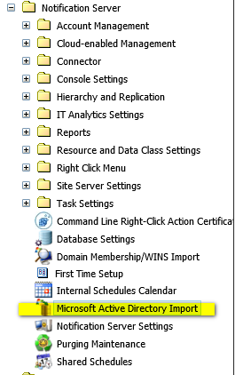

* Click 

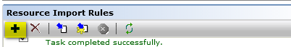

* Add info

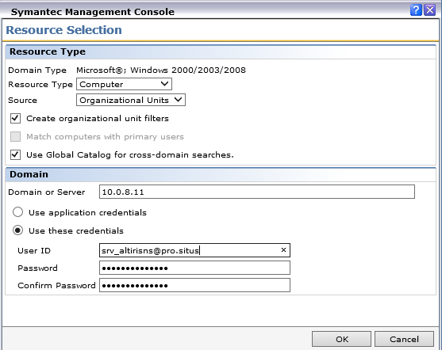

* Click “none”



* Select the correct OU

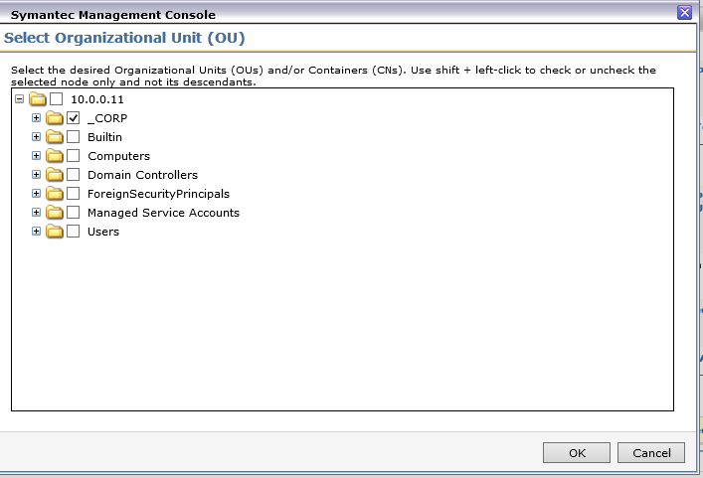

* Click “specified schedule” and create the following schedule. Make sure Weekly and Daily schedule are selected. Click OK to confirm.

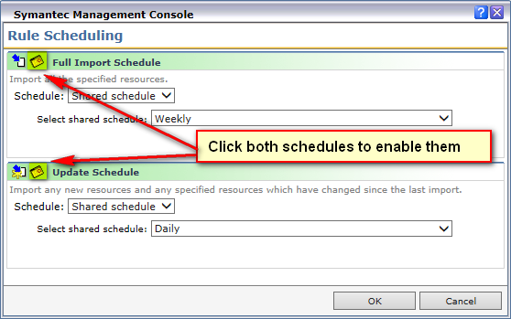

* Enable the newly created rule by clicking on the enable button



* Click on the title of the import rule and change put the name of the site/vessel in it according to the format used by previous rules.
* Save the created rule by clicking Save changes at the bottom of the page
* Select the newly created import rule , run the newly created import rule by clicking





### 4. Install Symantec Management Agent

- Copy the following files to C:\temp of the XXX-TASKS01 server

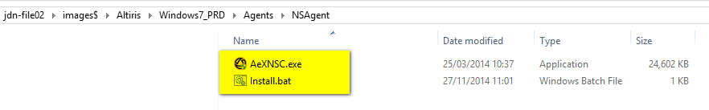

* Open Powershell as administrator
* Run .\AexNSC.exe -s -a ns="vm-alt-ns01.jandenul.com" path="E:\Altiris" /s

# Create Site

Go to settings > Notification server > Site Server Settings

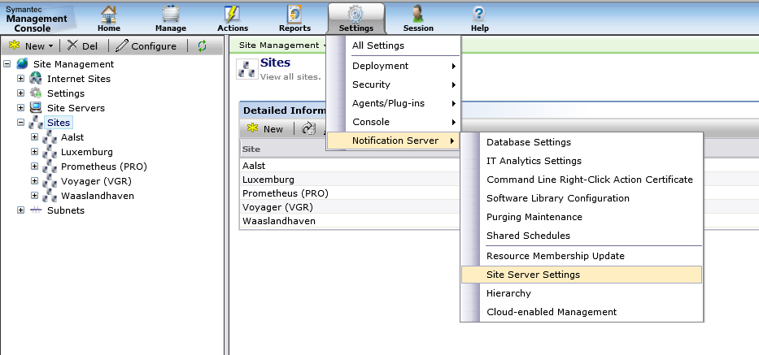

Go to Sites > Click “New”

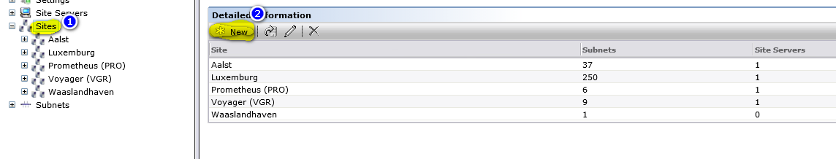

Insert full site / ship name + ( Abbreviation ) ex. Voyager (VGR)

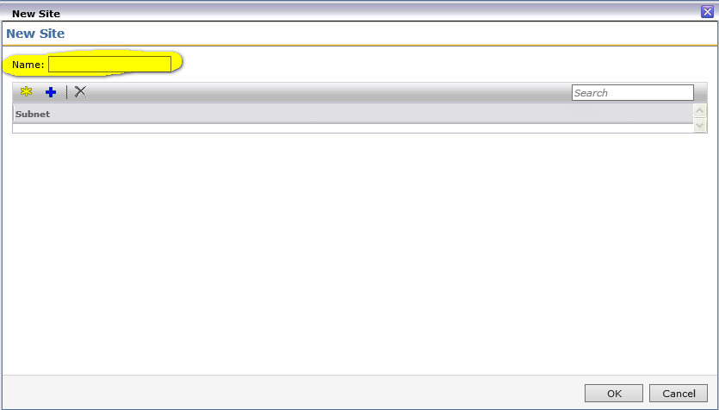

Create new subnet

If the subnets are not available, create them.

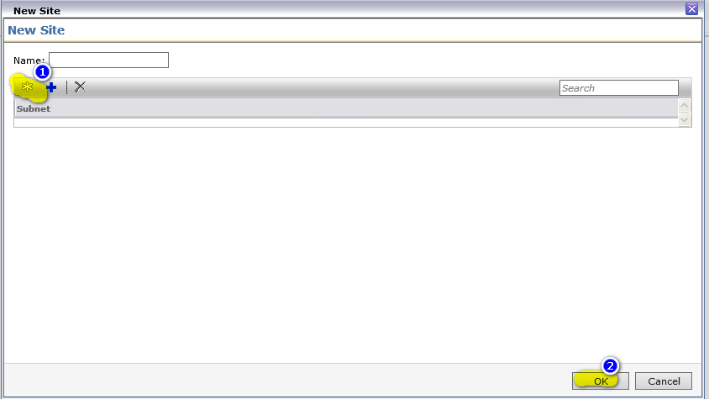

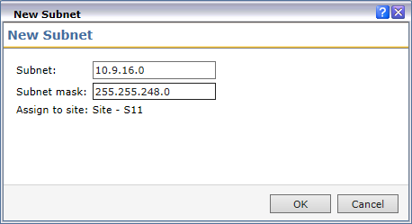

# Assign site server

### **Install Task and package service**

Select site servers > click “New”

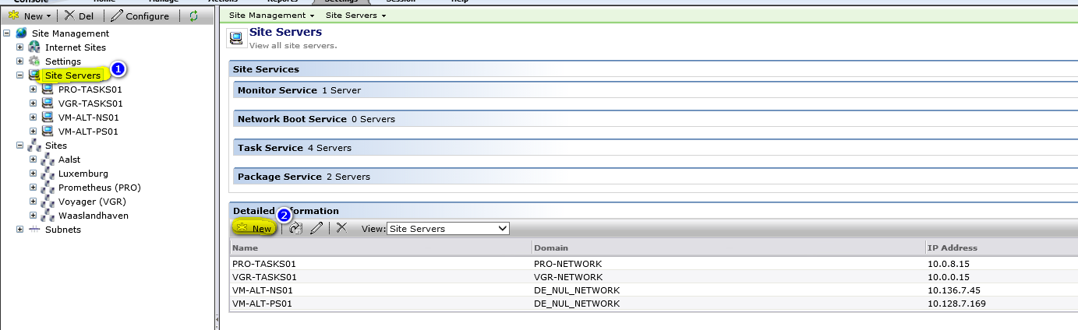

Choose the correct task server for that subnet

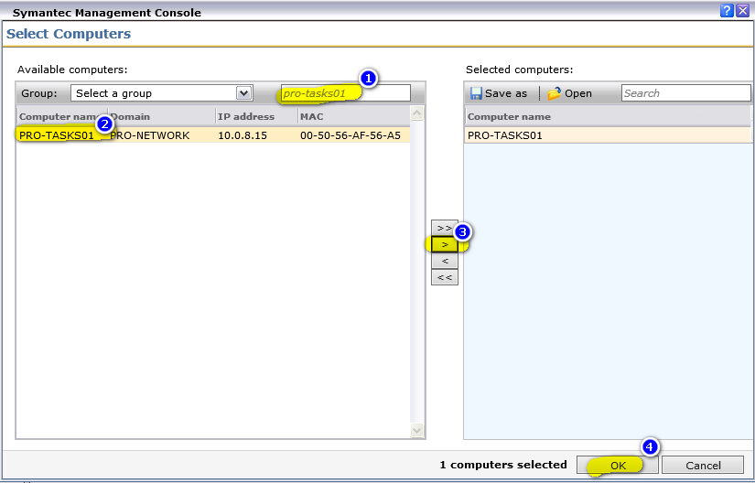

Select Package and Task service (Network boot service does not work with Cloud Enabled Management on).

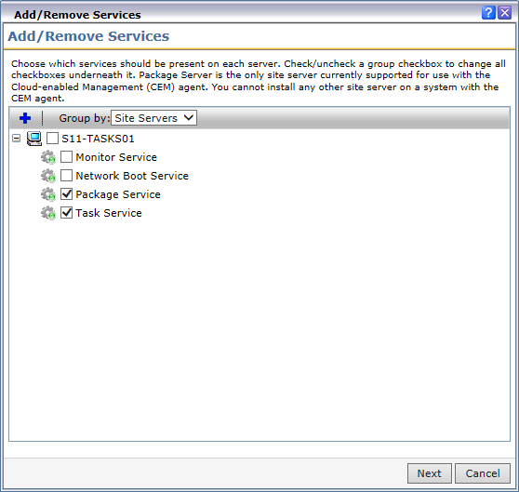

Click Next and then click Finish.

In the Symantec Management Agent Click “Update Configuration” to update the configuration



Wait until the tasks are done. Typically it will take 2 hours before the tasks will start automatically.

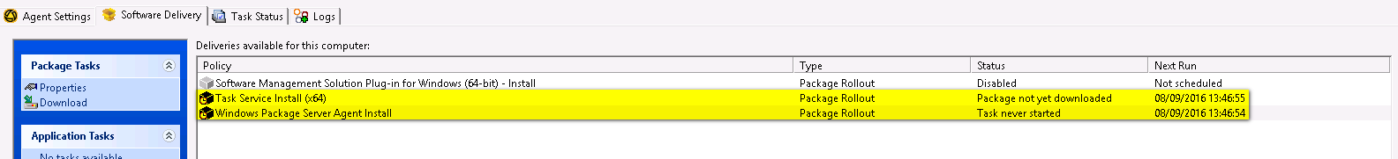

### **Sync software packages**

In order to sync the packages served by the package service you have 2 options:

* **Allow the package service to sync all data over the network (+/- 230 GB)**

This option can take quite some time. You can speed this up by disabling the bandwidth control option in the Agent settings tab. **Make sure you enable the bandwidth control again after syncing the packages!!!**

* **Copy the data from an external USB disk**

The USB disk is in the possession of the people installing the setups. Please ask them to connect the disk so you can copy the files. Once the disk is connected create a folder named Package Delivery in the E:\Altiris\Altiris Agent folder and copy all files contained on the USB disk to the Package Delivery folder. **Make sure you complete this step before the package service is installed.**

Wait until all services are installed and the packages are synced. You can follow this process in the console

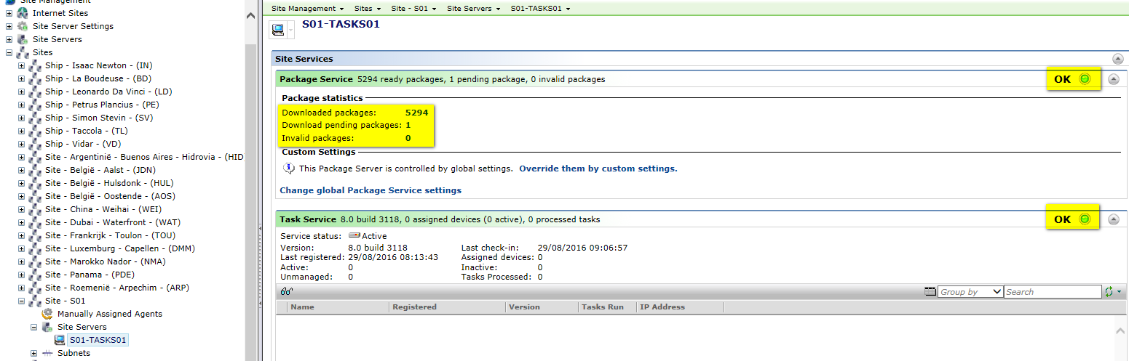

You can also check this progress on the Site server

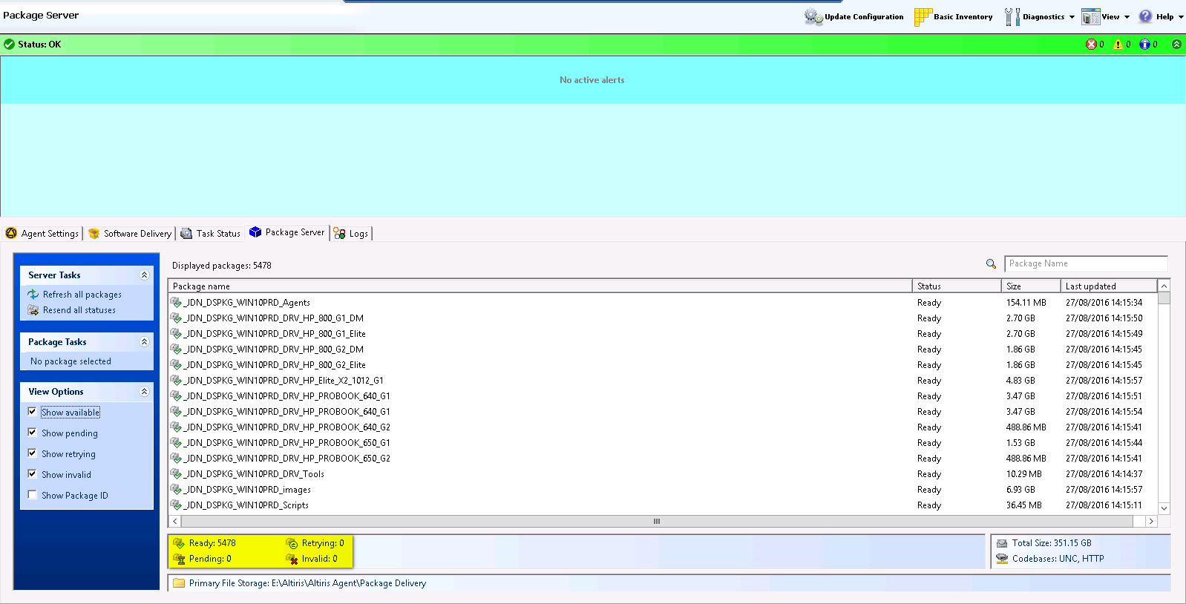

**!!! For Package servers not member of a domain the following has to be set on the package server !!!**

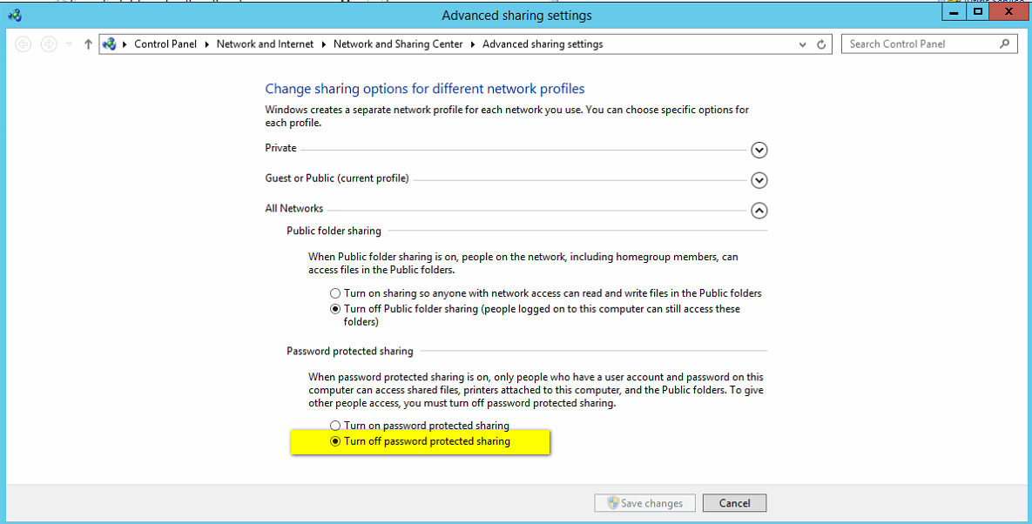

# Create and adjust filters

Go to Manage > Filters

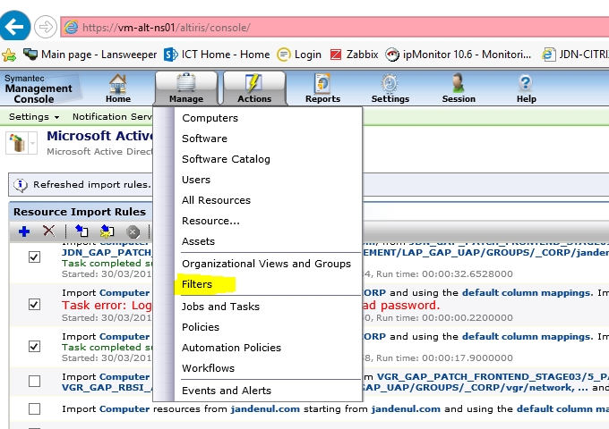

Go to Inventory Filters > Ships or Sites

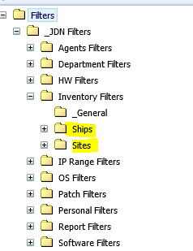

For **non Jandenul.com** sites / ships > right click and choose clone

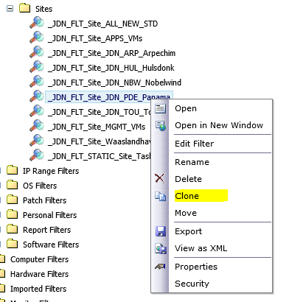

Fill in the correct name

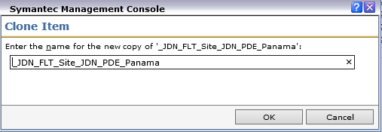

Click edit filter

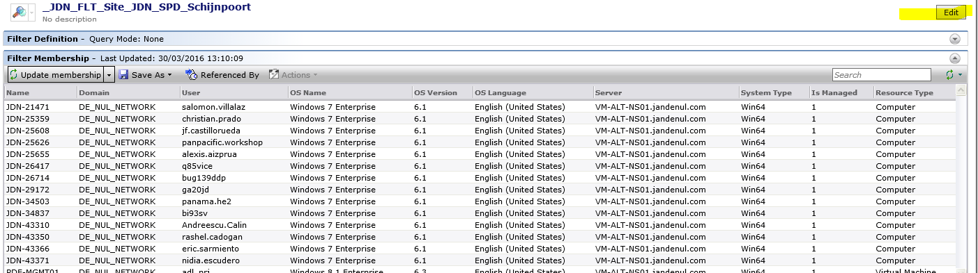

Select the _CORP/<site>/SITUS filter

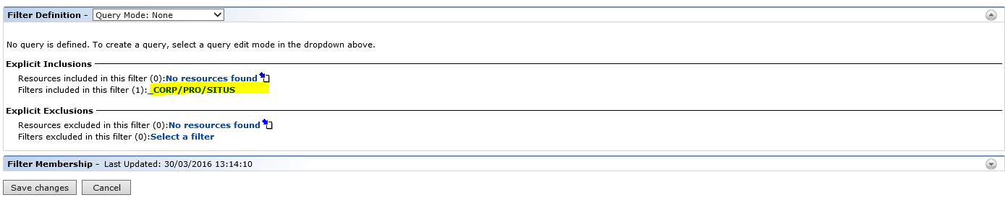

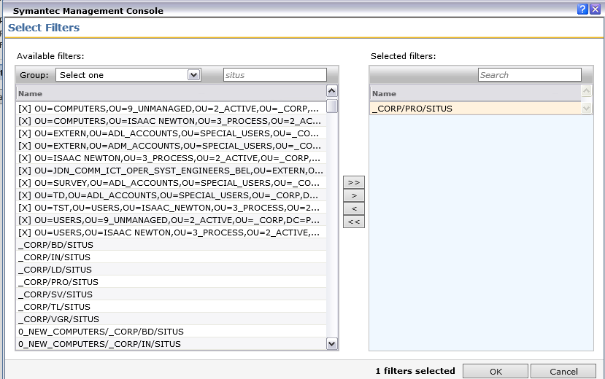

Click save changes

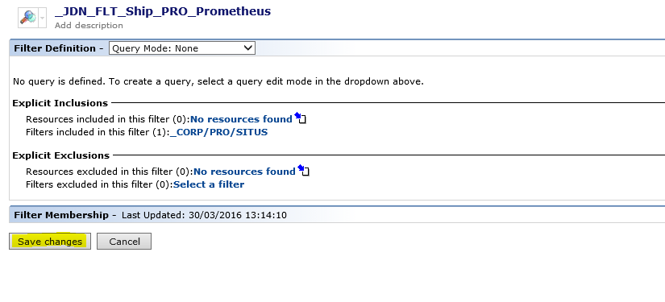

Add the filter you just created in the previous step to the _JDN_FLT_Ship_ALL_NEW_STD or the _JDN_FLT_Site_ALL_NEW_STD:

Ships:

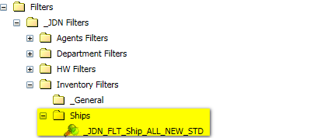

Sites:



Select the correct filter (ships or sites) and click edit and add the filter you created in the previous step to this filter

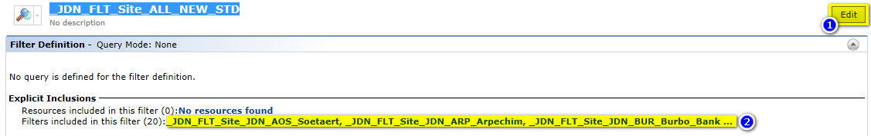

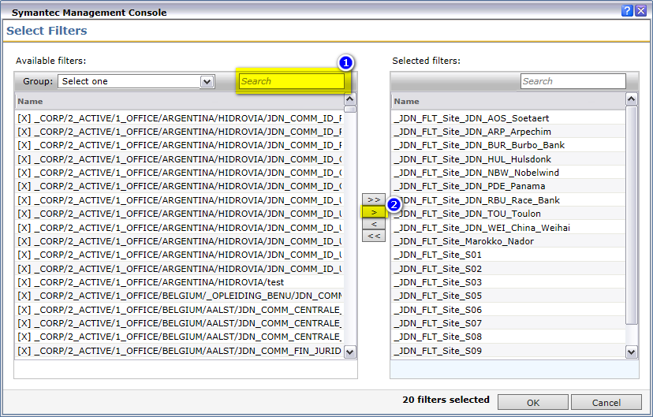

Add the task server to the static task server filter

Sites:

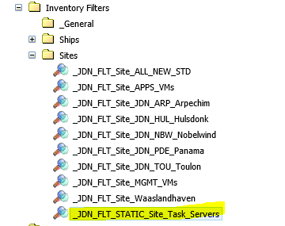

Ships:

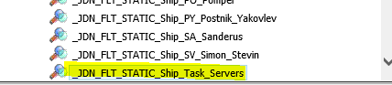

The part for **non Jandenul.com** sites / ships ends here.

For **jandenul.com** sites/ships > go to IP Range filters > right click and choose clone

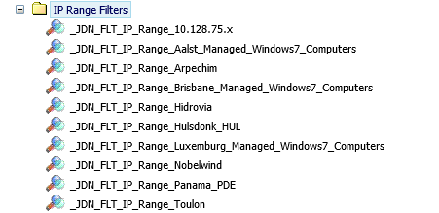

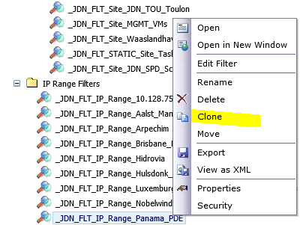

Edit the filter and adjust the ip ranges and save the changes

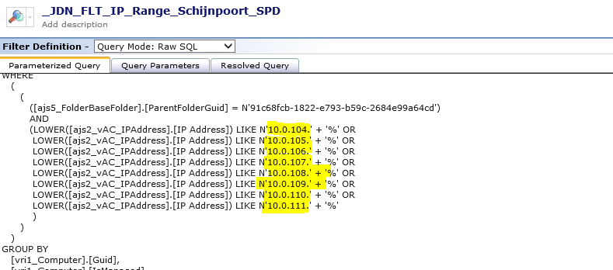

Go to Inventory filters > Sites > Clone existing filter

Edit the filter and add the IP Range filter created in the previous step

Add the filter you just created in the previous step to the _JDN_FLT_Ship_ALL_NEW_STD or the _JDN_FLT_Site_ALL_NEW_STD:

Ships:



Sites:



Select the correct filter (ships or sites) and click edit and add the filter you created in the previous step to this filter





Add the task server to the static task server filter

Sites:



Ships:

